**Balkumari College**

**(Affiliated to Tribhuwan University)**

Bharatpur- 11, Bhojad, Chitwan

[Subject Code:ICT.ED.485]

**A MINOR PROJECT REPORT ON**

**“ NREPcf}ifwLk;n”**

**“(Nepal Rate E- Pharmacy)”**



**Submitted by**

**Ranjita MasbeKumal [1501.]**

**NishantThapa [1523.]**

**NiranjanBista [1835.]**

**Anima Bhandari [ 1803.]**

**Submitted to**

**Department of BICTE**

**[Bachelor in Information and Communication Technology in Education]**

**2077**

# DECLARATION

We declare that the work presented in this project entitled “**Nepal Rate E-Pharmacy**” is uniquely designed by us. We also confirm that; the report is only prepared for our academic requirement and not for any purpose. All sources of information have been specifically acknowledged by reference to the author(s) or institution(s).

……………………..

Date:……………….. BICTE

8thsemester students

# RECOMMENDATIONS

This is to certify that the project work entitled **“Nepal Rate E- Pharmacy”**  inChitwan submitted by ***BICTE students*** [*Ranjita MasbeKumal ,Nishant Thapa , Anima Bhandari Niranjan Bista*] has been carried out under my supervision . The entire work was based on the result of their primary field work and has not been submitted for any other academic degrees. I ,therefore, recommend this project to be accepted for the partial fulfillment of Bachelor of Information and Communication Technology from BalkumariCollege, Chitwan, Nepal.

……………………………

……………………………

Sunil Sharma

Professor

Department of BICTE

Balkumaricollege

Tribhuvan University Chitwan,Nepal

Date:……………………

**TRIBHUVAN UNIVERSITY**

**BALKUMARI COLLEGE**

**BHARATPUR, CHITWAN,NEPAL**

# LETTER OF APPROVAL

On the recommendation of supervisor Sunil Sharma, ,Shree ParsadAryal this project entitled “**Nepal Rate E-Pharmacy”** in Chitwan at Balkumaricollege by BICTE students ,has been approved for the examination and submitted to Tribhuvan University in the partial fulfillment of requirements for Bachelor of Information and Communication Technology.

**EXPERT COMMITTEE**

…………………………. ………………………..

(Supervisor) Shree Prasad Aryal

Sunil Sharma, Head of department of BICTE

Professor Balkumaricollege

Department of BICTE Tribhuvan University

Balkumari College Chitwan ,Nepal

Tribhuvan University

Chitwan,Nepal

…………………………………… ………………………………….

(External Examiner) (Internal Examiner)

Date:………………………

# ACKNOWLEDGEMENT

First of all, we offer our sincerest gratitude to the *supervisor* **Mr.Sunil Sharma** for guiding and correcting various documents for this project work with attention and care. He gave us his valuable time when necessary without feeling any difficulties.

We will be always thankful to **Mr. Shree ParsadAryal (***HOD , Department of BICTE*) for providing administrative facilities and valuable suggestion and encouragement .His guidance helped us during the entire period of project work time. We would also like to thank to all faculty members of *BICTE* in Balkumaricollege for their kind support .

Finally, We are very thankful to all my family members and friends for their support ,encouragement, suggestion and genuine love that made our project work a success. We express our gratitude to all those who made this project come into existence.

We owe a great many thanks to great many people who helped and supported us during the course of this project work.

Ranjita MasbeKumal

NishantThapa

NiranjanBista

Anima Bhandari

Department of BICTE

Balkumaricollege

Chitwan, Nepal

# ABSTRACT

21st century is known as the era of science and technology (*DIGITAL WORLD)*. Nowadays,

Digital marketing is also popularly known as online marketing. People used to purchase things through online due to *convenience*.So, we surf different websites and collects the data of online marketing .The present project was conducted from January to March. Three sites i.e. *CTEVT, NPI* and *CMC* medical college of Chitwan district was designated for the survey of this project. During the collection of data *Questionnaire* and *interviews* to pharmacist and MR. We concluded the merits and demerits of online pharmacy in Nepal. The advantages of online pharmacies are privacy, avail great choice, lower prices and convenience mainly. Similarly ,the disadvantage include lack of physical evaluation in place ,some do not dispense drugs through licensed pharmacies, some online pharmacies do not adequately safeguards patient’s health, some do not adequately protect personal and financial information. In this pandemic period of *Covid-19*, the scope of online pharmacy plays vital role in today’s context. No doubt online pharmacy improves consumer convenience and access and this will give benefits to elderly patients suffering from chronic ailments because they need to visit pharmacy to buy medicines.

**Keywords: Online, Pharma, Retail**

Table of Contents

DECLARATION i

RECOMMENDATIONS ii

LETTER OF APPROVAL iii

ACKNOWLEDGEMENT iv

ABSTRACT v

LIST OF FIGURE: ii

LIST OF TABLE: iii

CHAPTER I: INTRODUCTION ii

1.1 BACKGROUND: ii

1.2 : Aims: iii

1.3: Objectives: iii

CHAPTER II: METHODOLOGY iv

CHAPTER III: STRUCTURE OF THE PROJECT 11

CHAPTER IV: SYSTEM DESIGN 13

CHAPTER VI: TIME FRAMEWORK 18

5.1. Project Gantt Chart 18

EXPECTED OUTPUT 19

Conclusion: 20

REFERENCES: 21

# LIST OF FIGURE:

Figure no:3.1. Incremental development model

Figure no:. ER diagram

# LIST OF TABLE:

Table 1: Summary of methodology

Table 2: Gantt chart

# CHAPTER I: INTRODUCTION

## 1.1 BACKGROUND:

Digital Marketing is very popular now a day where in all the companies are promoting their business through digital technologies. Digital marketing is also popularly known as online marketing or internet marketing. Online medicine purchase is popular worldwide due to convenience. Indian healthcare market is growing at good speed and presently both online and offline pharmacies are doing business. The global E-pharmacy market, led by North America and Europe ,was approximately US$ 29.3 billion in 2014 and has been estimated to grow at a CAGR of 17.7% to reach a valuation of US$ 128 billion by 2023(FICCI,2016). Out of this market online pharmacies have less then 5% market share but the growth rate is double digit. The Indian pharmacy market is huge ,estimated by industry to be around Rs 1.2 lakh core in size and out of that the online pharmacy market. (Economic Times ,2017) The growth of online companies are imposing huge threat to these offline companies. As a result of this offline pharmacies are united together and on October 2015 the retailers shut their shops as a mark of protest against the online drug retail business.

According to (Shankar et al. 2011) now customers are using social media like Twitter, Facebook, MySpace ,and linked In etc. and depend on them for taking marketing shopping decisions, thus promotion through these media has become important. Curran et al.(2011) opined that social media sites such as Facebook is much better option than other advertising processes as it stores information of its users . According to (Ovaskainen ,2001) WHO is really concerned with internet sales which may bypass national drug regulatory authorities, allow medical products on the market which are un approved, fraudulent, unsafe or ineffective even. George (2009) studied on internet pharmacies and recommended regulation approach on global basis. Increasing internet and smart phone users prove that India have a bright future of online pharmacy, although this will bring few challenges with opportunity(Priyanka& Ashok,2016).

## 1.2 : Aims:

The aims of our project is to provide a user- friendly interface for consumers for easy buying process. It saves a lot of time and effort for patient/ consumers as they can conveniently purchase medicine. It is mainly used for digital marketing of medicine in Nepal.

## 1.3: Objectives:

* To notify the consumers about E-Pharmacy in Nepal.
* To save consumers time and provide conveniently purchase medicine.
* To provide reasonable price and privacy

# 

# CHAPTER II: METHODOLOGY

Since, every project has its own aims and objectives that need to be fulfilled which motivated and lead us to fulfill our aim of carrying out the project. For achieving the goals, we use the mixed qualitative and quantitative method.

For our minor project, lots of work has to be done regarding the web pages. Webpage are an important part of the any organization because it is the main source to view the information of the medicine/drugs for the consumer service. Since it is been using the manual process for the reservation which is not effective to achieve the goal for the smooth development of the based on customer service by realizing that websites for Pharmacy. So, we try to develop it as a part of our minor project.

For this we will perform, a review from which we will generate the ideas.

* How the best websites should be look like?
* What sort of patient should we focus?
* What are the content that should be in the webpage?

Moreover, the reviews will help in finding the contents that are necessary for the web pages.

After the successful completion of reviewing the webpage we perform the interview. There are different type of interview but we follow the semi-structured interview because this type of interview helps the interviewee to share their ideas and provide us guidance about the basic and important content of the websites and enhancing the web range of the information. So, secondary we perform this interview in order to gather data and information for the webpage. These information or data will be collected from review and by interviewing pharmacist, medical representative, and the public people for the informative, attractive and user friendly web pages.

The identified data and information will then be analyzed by the project coordinator in order to bring the required and important data and information.

The methodology we have mention is better on as it help in finding the data and information required for website.

We divide the project into four phase. Each phase produce specific operation that will be used for analysis and conclusion.

Each phase is described below along the specific operation produced by it.

**Phase I:**

In this phase, relevant data and information about webpage will be collected by reviewing the existing web-page. As well as we viewed other webpages to gain the basic information for our webpages.

**Phase II:**

This phase is two folded:

* First to validate the finding of reviews or we can say the validate the finding of phaseI. And determining the importance of those review of the websites.
* Secondly to identify additional information that are missed in phase-I. For this we will conduct interview with the pharmacist ,MRand possible user of webpage.

This phase provides the project team the detail idea how the websites will be and what content are essential for the websites.

**Phase III:**

This is the main phase where we analyze the finding of the phase-I and phase-II. Here, team members and team coordinator will actively act on chosen the required information for the web-page.

**Phase IV:**

In this phase all the information that has been gathered required for the web-page will be implemented in real application. Then the team co-ordinate along with project team will decide the tools for developing the web-page scripting language to make the page dynamic. Here we decide to use Bootstrap to develop the dynamic webpage for the customer services.

*Table 1: Summary of methodology*

|  |  |
| --- | --- |
| Phase | Methodology |
|  |  |
| Phase-I | Review |
|  |  |
| Phase-II | Semi-structured interview |
|  |  |
| Phase-III | Gathering and analyzing the requirement |
|  |  |
| Phase-IV | Determining tools and scripting language to make |
|  | page dynamic |
|  |  |

# CHAPTER III: STRUCTURE OF THE PROJECT

Software engineering is an engineering discipline that is concerned with all aspects of software production from the early stages of system specification through to maintaining the system after it has gone into use.

Software engineering is the discipline whose aim are follows:

1. Production of quality software
2. Software that is delivered on time
3. Cost within the budget
4. Satisfies all requirements

A software process model is an abstract representation of a software process. Each process model (sometimes called process paradigms) represents a process from a particular perspective, and thus provides only partial information about that process.

These generic software process models are not definitive descriptions of software processes. Rather, they are abstractions of the process that can be used to explain different approaches to software development.

The process models are:

1. *The waterfall model*
2. *Incremental development*

In the project , we followed Incremental development model.

Outline description

Specification

Development

Validation

Initial version

Intermediate versions

Final version

Fig.3.1. Incremental developmentmodel

Incremental development has three important benefits compared to the waterfall model:

* The cost of accommodating changing customer requirements is reduced
* It is easier to get customer feedback on the development work that has been done.
* More rapid delivery and deployment of useful software to the customer is possible, even if all of the functionality has not been included.

**Advantages :**

* Results are obtained early and periodically.
* Parallel development can be planned.
* Progress can be measured.
* Risks are identified and resolved during iteration; and each iteration is an easily managed milestone.

**Disadvantages:**

* It is difficult to map requirements directly to different increments.
* An overhead in the model is rapid context switching between various activities.
* Each iteration is followed by an evaluation ensuring that user requirements have been met. This evaluation after each iteration is time consuming.

# CHAPTER IV: SYSTEM DESIGN

In this phase the software’s overall structures are defined. In terms of client server, technology the number of tiers needed for the package architecture, database design, data structure design etc. are defined in this phase. The following are the essential approach taken during web portal designing:

* ER –Diagram

**ER DAIGRAM**

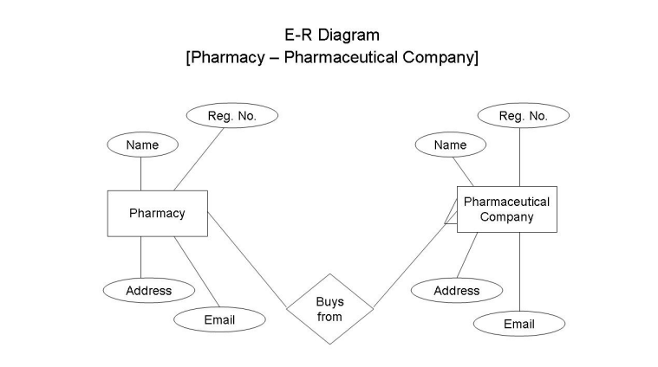

**1.ScreenshotsFigure:4.1**

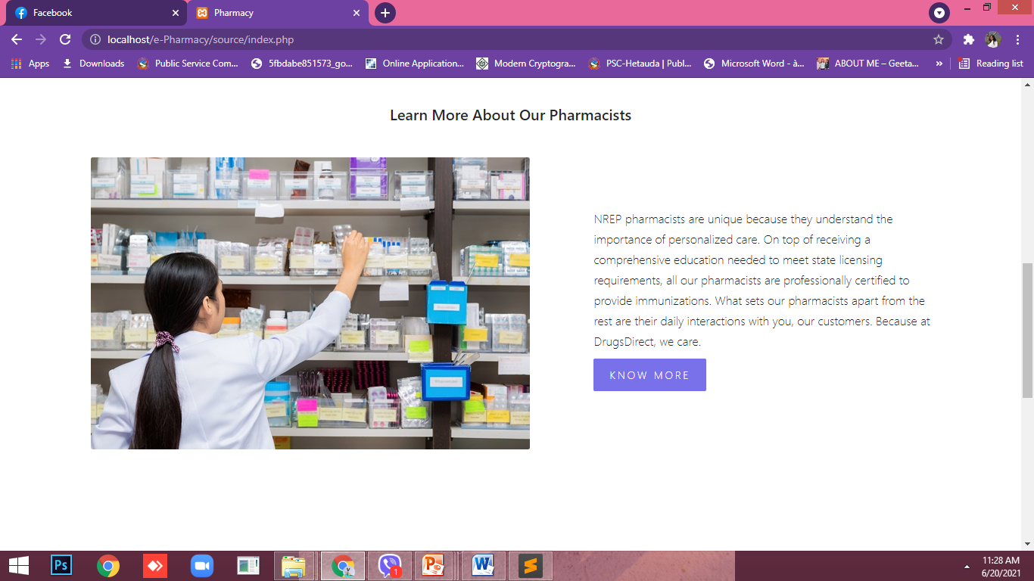

**Figure:4.2**

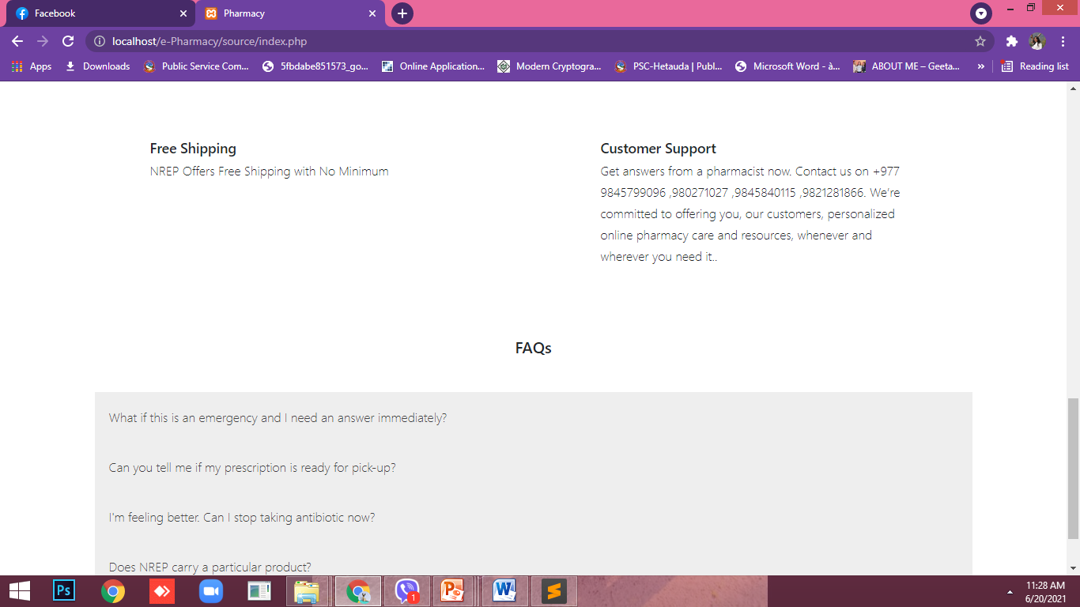

**Figure:4.3**

**About us:**

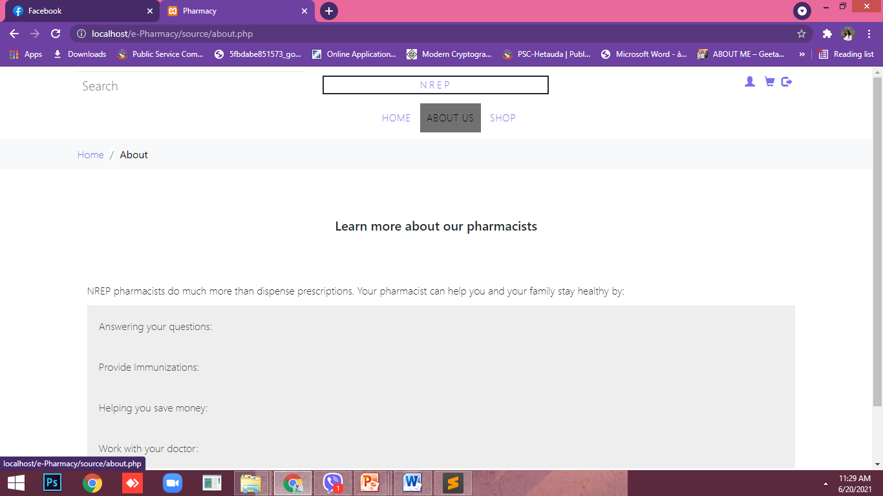

**Figure:4.5**

**Shop now:**

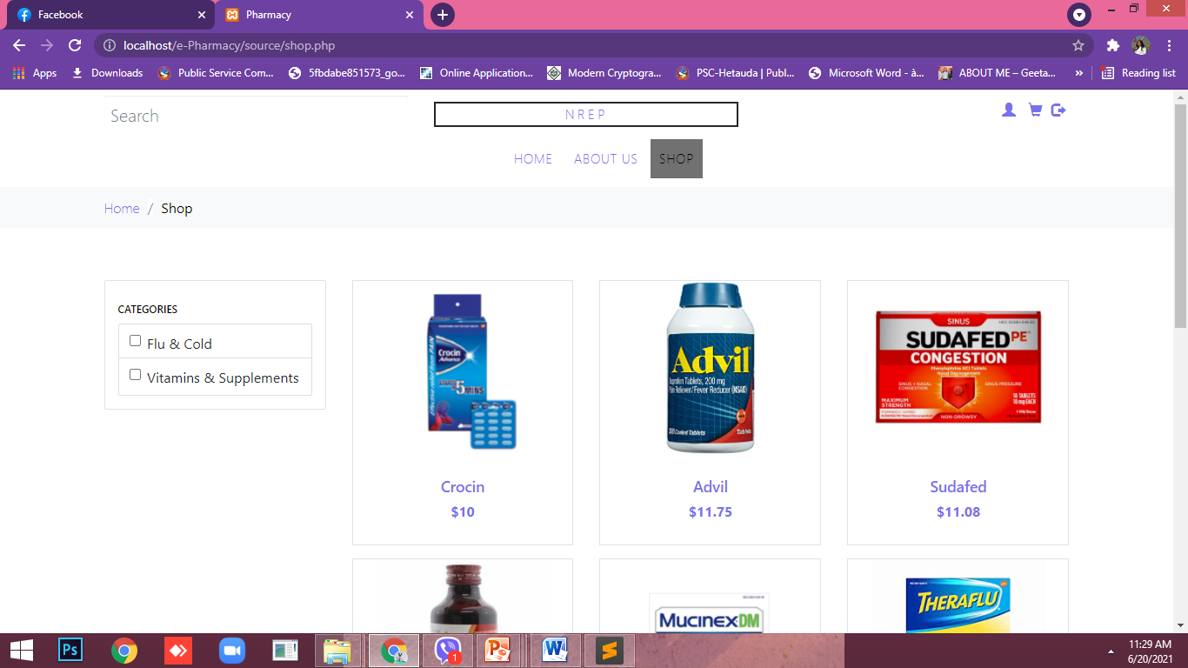

**Figure:4.7**

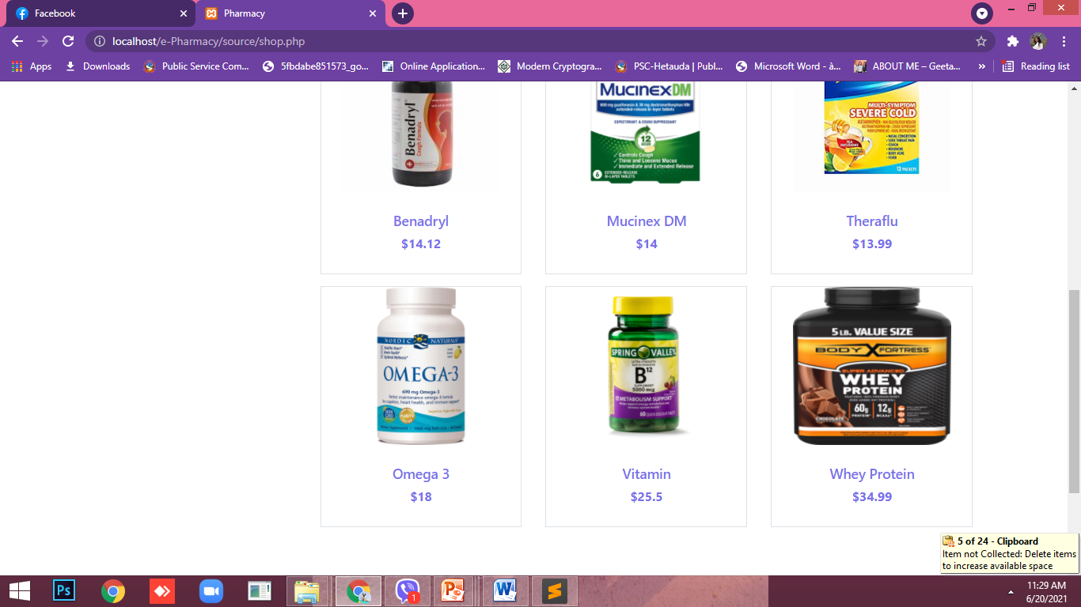

**Log In page:**

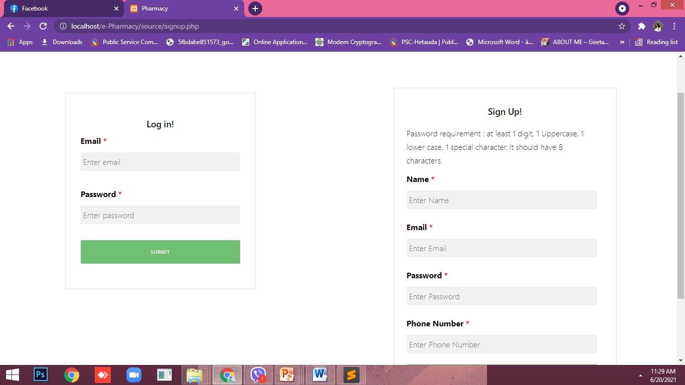

**Figure:4.8**

# CHAPTER VI: TIME FRAMEWORK

## 5.1. Project Gantt Chart

A Gantt Chart is one of the most popular and useful ways of showing tasks (activities or events)

displayed against time. The Gantt chart of our project is given below:

*Table 2: Gantt chart*

|  |  |  |  |  |  |  |  |  |  |  |  |  |  |
| --- | --- | --- | --- | --- | --- | --- | --- | --- | --- | --- | --- | --- | --- |
| *Week*  *Stages of project* | *1* | *2* | *3* | *4* | *5* | *6* | *7* | *8* | *9* | *10* | *11* | *12* | *13* |
| *Selection of project* |  |  |  |  |  |  |  |  |  |  |  |  |  |
| *Selection of topic* |  |  |  |  |  |  |  |  |  |  |  |  |  |
| *Detailed analysis and study* |  |  |  |  |  |  |  |  |  |  |  |  |  |
| *Initial prototype* |  |  |  |  |  |  |  |  |  |  |  |  |  |
| *Mid term Defense* |  |  |  |  |  |  |  |  |  |  |  |  |  |
| *Implementation of system* |  |  |  |  |  |  |  |  |  |  |  |  |  |
| *Testing* |  |  |  |  |  |  |  |  |  |  |  |  |  |
| *Documentation of project work* |  |  |  |  |  |  |  |  |  |  |  |  |  |
| *Final Defense* |  |  |  |  |  |  |  |  |  |  |  |  |  |

# EXPECTED OUTPUT

After the completion of our project, we have expected the web-page of E- Pharmacy will be more responsive, contains all the requirements and user friendly. We can have the all the required information about the medicine details about the authorized letter by doctor.

# Conclusion:

Wehavedevelopedan e-commercewebsitefor onlinepharmacy.Afterloggingin,theavailable products/servicesinthe systemare listedtotheuser. Any medicinecan besearchedinthe searchbox. Theusercanalsofilteroutthemedicinesbasedoncategoriesprovided.Paging functionalityforlisting products/serviceshasbeenimplemented.Afterselectingaparticularmedicine,theusercanupdatethe quantityof theproduct.Usercanalsoupdateitems inthecart,likeremovingitemsfromthecartand updating theproduct’squantity. Theprojectalsoshowsthehistory ofpurchases orsavedlistsforthe user.Afterselecting theproducts,theusergoesforthepayment optionand entersthebillingdetails.In thebillingsection,promo codeordealcodecanbeapplied,resultinginsomediscountforthefinalbill dueFortheadminpart:Theadmincanview,deleteandinserttheproductsandcategorytothetable.He/she can alsoviewtheusers andtheirorders.

# 

# REFERENCES:

1. (Economic Times ,2017)
2. (Shankar et al. 2011)
3. (Curranet al.(2011)
4. (Ovaskainen ,2001)
5. (Priyanka& Ashok,2016).
6. <https://www.clinicone.com.np/doctor-profile/>
7. <https://www.1mg.com/drugs/dermi-5-cream-357049>
8. [www.garvimedical.com](http://www.garvimedical.com/?fbclid=IwAR3D8AAjjCtOR_lC8XLtylqYoXVR-rMGnuEIxG77-6sakMrARl6Cl236pnc)